Customer Satisfaction Report New Forest Physiotherapy Clinic 2015.

This is the break down and analysis of the results gathered from the New Forest Physiotherapy patient satisfaction reports. Patients were asked to fill out a short questionnaire during their course of treatment. Treatments was carried out by 3 therapists. Holly and Adam- Physiotherapists and Edith- Sports therapist, over the year of 2015.

Patients were asked to rather the following:
1). The efficiency and ease of telephone contact
2). The time availability of the appointment times offered
3). The waiting area facilities
4). The punctuality of therapist
5). The explanation of your diagnosis and treatment
6). The overall standard of care you received
7). Would you recommend us to a friend?
8). What could we have done better?

Results:
Questions 1-6 were rated from 1(poor) to 5 (excellent)
Question 7 was simply “yes” or “no” answer
Question 8 gave space for “other comments”

A total of 28 questionnaires were completed during this time. Results have been compared to those collected in 2014 and 2011. These two years has been chosen as the results gathered are reliable and clearly laid out in statistical format. They have also been used as a 3-year time gap should show to be enough time for an improvement to occur within sections. Here are the results:

What percentage of results was in the ‘higher tier’
Higher tier is a tier I have created which is made up of ratings ‘very good’ (4’s) and ‘excellent’ (5’s). NFPS should be aiming to get into Top Band, in order to provide the best experience for patients.

(Q1). The efficiency and ease of telephone contact

(1= poor 5= excellent)

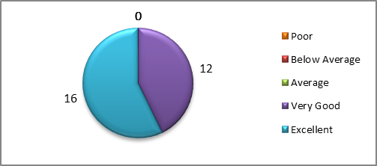

Q1 | Poor | Below Average | Average | Very Good | Excellent | Total
 | 0 | 0 | 0 | 12 | 16 | 28

- 100% of patients perceived the efficiency to be within the top band (Ratings 4/5’s) ongoing from 2014 results.
- 2011 results – 92.3% in higher tier.

(Q2). The time availability of the appointment times offered

(1= poor 5= excellent)

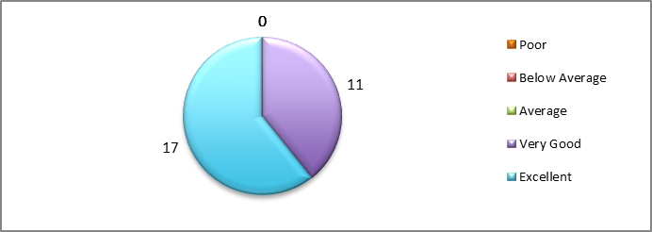

Q2 | Poor | Below Average | Average | Very Good | Excellent
 | 0 | 0 | 0 | 11 | 17 | 28

- 100% of patients perceived the availability of appointment times to be within the top band (Ratings 4/5’s) improvements from previous year.
- In 2014 89.4% of patients perceived the availability of appointment times offered to be within the top band (Ratings 4/5’s).
- 2011 results – 84.6% in higher tier.

(Q3). The waiting area facilities

(1= poor 5= excellent)
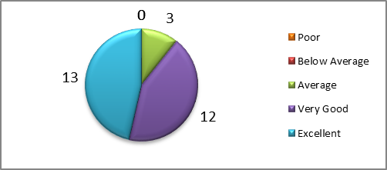

Q3 | Poor | Below Average | Average | Very Good | Excellent
 | 0 | 0 | 3 | 12 | 13 | 28

- 89.2% of patients perceived the waiting area facilities to be high quality, improvements from the previous year (73.6%)

(Q4). The punctuality of therapist

(1= poor 5= excellent)

Q4 | Poor | Below Average | Average | Very Good | Excellent
 | 0 | 0 | 0 | 4 | 24 | 28

- 100% of patients perceived the punctuality of the therapist to be within the top band (Ratings 4/5’s) the same as previous year.
- 2011 result – 84.6% in higher tier

(Q5). The explanation of your diagnosis and treatment

(1= poor 5= excellent)
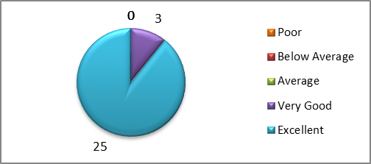

Q5 | Poor | Below Average | Average | Very Good | Excellent | Total
 | 0 | 0 | 0 | 3 | 25 | 28

- 100% of patients perceived the explanation of diagnosis and treatment to be within the top band (Ratings 4/5’s)
- 2011 result – 84.6% in higher tier

(Q6). The overall standard of care you received

(1= poor 5= excellent)

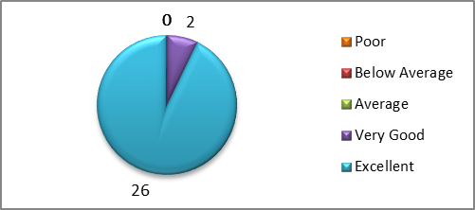

Q6 | Poor | Below Average | Average | Very Good | Excellent
 | 0 | 0 | 0 | 2 | 26 | 28

- 2014 and 2015 100% of patients perceived the overall standard of care received to be within the top band (Ratings 4/5’s)
- 2011 result – 69.2% in higher tier

- Question 7: Would you recommend to a friend?

- 100% would recommend us to a friend.
2011and 2014 result - 100% would recommend us to a friend

Question 8: what could we have done better Other comments:

Overall all comments were very positive many responded “nothing” to this question. No negative comments were made the only area for improvement which was mentioned was in regards to reception and waiting area of the building which was similar to previous year. Patients scored the waiting room and reception area at its lowest. However on evaluation there is little that can be done for the situation and location of the clinic. However in order to improve the waiting room a separate patient questionnaire could be developed to ask patients what they would expect from the seated area and where improvements can be made. In addition to this some patients mentioned it would be beneficial to put up a sign on the main road with New Forest physiotherapy clinic so patients coming for the first time can see the location more clearly.

From looking at the data collected in 2011 and 2014 there has been an improvement in each area across the board in 2015, with more elements scoring 100% in the higher tier. Other comments included:

- Patients found that the text message reminders for appointments very helpful.
- Excellent personal care,
- Kind and understanding therapists
- Relaxing natural atmosphere.
- Very kind and helpful staff
- Professional environment
- Felt supported through treatment

