PLEASE COMPLETE ALL 5 PAGES PRIOR TO FIRST APPINTMENT

****IMPORTANT UPDATE****
On 1st January 2024 the clinic relocated to
40 Kingfisher Way, Marchwood, Southampton SO40 4XS
For directions visit http://www.newforestphysio.co.uk/marchwood-40-kingfisher-way/

PHYSIOTHERAPY CONSENT FORM

Terms and Conditions of treatment at New Forest Physiotherapy Clinic Southampton

1) I give consent to physiotherapy assessment and treatment at New Forest Physiotherapy Clinic Southampton.

2) I understand that if I fail to attend an appointment with out providing 24 hours notice I will be charged for that appointment or will loose one of my insurance appointments.

3) I consent to my physiotherapist contacting my GP/consultant/other medical professional if necessary.
If it is clinically necessary we may need to contact your GP/consultant/other medical professional. We will inform you if we need to contact them.

4) I consent to New Forest Physiotherapy Clinic contacting me with appointment reminders, exercise sheets, clinical letters and newsletters about important clinic business (eg if your appointment needs to be rearranged) as necessary. You can unsubscribe from newsletters whenever you like.

5) INSURANCE PATIENTS: I agree to pay any insurance excess at my first appointment or when invoiced by New Forest Physiotherapy Clinic.

6) SELF FUNDING PATIENTS: I agree to paying the following physiotherapy fees;
Assessment 1 hour £60
Treatment 30 mins £40
Pre-payment package 6 treatment sessions £192 (£32 per session)

Patient / Guardian Signature: ……………….…

Date: ……………..

Physiotherapist: Adam Smith-Connor
Health Check List
Please complete this health-screening questionnaire, which will help us to assess your needs.

Do you suffer from any of the following conditions / symptoms?
Delete as appropriate (If yes please provide full details below)
Diabetes (Type I or type II) Yes No
Epilepsy Yes No
Headaches or migraine Yes No
Heart conditions (eg angina, heart attack, heart murmur) Yes No
Lung conditions (eg asthma, bronchiectasis, COPD, tuberculosis) Yes No
Haemophilia / taking blood thinners Yes No
Cancer Yes No
HIV Yes No
Bone Conditions (eg osteoporosis, RA) Yes No
High blood pressure Yes No
Low blood pressure Yes No
Back pain Yes No
Muscle, nerve or joint problems Yes No
- E.g. arthritis, repetitive strain injury,
- Recurrent injuries, carpel tunnel syndrome
Stroke or head injury Yes No
Genetic disorders (eg cystic fibrosis, muscular dystrophy) Yes No
Neurological conditions (eg MS, Guillain Barre syndrome) Yes No
Unexplained weight loss Yes No
Abnormal bowel or bladder function (E.g. constipation/diarrhoea/urinary incontinence/retention)
Yes No
Muscle Weakness (E.g. dropping things/dragging your feet) Yes No
Difficulty Speaking (E.g. slurred speech, difficulty finding the right words) Yes No
Double Vision Yes No
Mental health problems (eg. depression, anxiety) Yes No
Dizziness, labarynthitis or vertigo Yes No
Are you currently pregnant / think you might be pregnant? Yes No N/A
Have you fractured any bones in the past? Yes No
Do you have any metal implants Yes No
Do you have a pacemaker Yes No
Do you suffer from any allergies Yes No

Please list any operations you have had with dates.

Please list all your current medications (including blood thinners and steroids).

Please use this space to list any other conditions, not already mentioned above.

Please explain the reason for your visit (e.g. back pain/unable to reach up, etc.)

Where does your pain occur? (Please mark on the diagram below with an ‘X’ & describe below)

Please score each area of pain (on the diagram) from: 0 (No pain) to 10 (Extreme pain)
Please mark on the any areas of numbness or pins and needles with an ‘O’
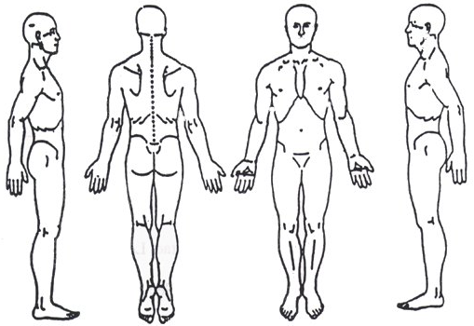

Describe your pain (throbbing, burning, aching, stabbing, etc)

When did this pain begin? Please provide approximate date.

What caused your pain? (E.g. Car crash, fall, repetitive movement, sport, unknown, etc.)

What activities worsen the pain? (E.g. bending, heavy lifting, sneezing, reaching up, etc.)

What relieves your pain? (E.g. Pain killers, hot water bottle, stretching, etc.)

Have you had any previous treatment for this problem? (If yes, please provide details below)

Please rate your pain on severity from 0 (No pain) to 10 (Extreme pain), at these different times of the day: (Please circle)
Morning

0 1 2 3 4 5 6 7 8 9 10

Afternoon
0 1 2 3 4 5 6 7 8 9 10

Evening
0 1 2 3 4 5 6 7 8 9 10

Has the pain affected your sleep in any way? YES NO

Have you had any investigations into your pain? YES NO
(E.g. X-Ray, MRI scan, ultrasound, blood test, etc. If yes, please provide details below)

What do you do for a living?

List any regular sports or hobbies you do

